WEEK 4

Mandatory Hands-On

**Spring REST using Spring Boot**

**Get Country based on Country code**

**Creating CountryService Class:**

* CountryService class Is created under the package *com.cognizant.springlearn.service*.

**CountryService Class:**

package com.cognizant.springlearn.service;

import java.util.List;

import java.util.Optional;

import org.springframework.context.ApplicationContext;

import org.springframework.context.support.ClassPathXmlApplicationContext;

import org.springframework.stereotype.Service;

import com.cognizant.springlearn.model.Country;

*@Service*

public class CountryService {

public Country getCountry(String code) {

ApplicationContext context = new ClassPathXmlApplicationContext("country.xml");

*@SuppressWarnings*("unchecked")

List<Country> countries = (List<Country>) context.getBean("countryList");

Optional<Country> country = countries.stream()

.filter(c -> c.getCode().equalsIgnoreCase(code))

.findFirst();

return country.orElseThrow(() -> new RuntimeException("Country not found with code: " + code));

}

}

**Updated Country Controller class:**

package com.cognizant.springlearn.controller;

import org.springframework.beans.factory.annotation.Autowired;

import org.springframework.web.bind.annotation.*;

import com.cognizant.springlearn.model.Country;

import com.cognizant.springlearn.service.CountryService;

*@RestController*

public class CountryController {

*@Autowired*

private CountryService countryService;

*@GetMapping*("/countries/{code}")

public Country getCountry(*@PathVariable* String code) {

return countryService.getCountry(code);

}

}

**Updated country.xml file:**

<?xml version="1.0" encoding="UTF-8"?>

<beans xmlns="http://www.springframework.org/schema/beans"

xmlns:xsi="http://www.w3.org/2001/XMLSchema-instance"

xsi:schemaLocation="http://www.springframework.org/schema/beans

http://www.springframework.org/schema/beans/spring-beans.xsd">

<bean id="countryList" class="java.util.ArrayList">

<constructor-arg>

<list>

<bean class="com.cognizant.springlearn.model.Country">

<property name="code" value="IN"/>

<property name="name" value="India"/>

</bean>

<bean class="com.cognizant.springlearn.model.Country">

<property name="code" value="US"/>

<property name="name" value="United States"/>

</bean>

</list>

</constructor-arg>

</bean>

</beans>

**SME:**

* In chrome <http://localhost:8083/countries/in> is opened.
* 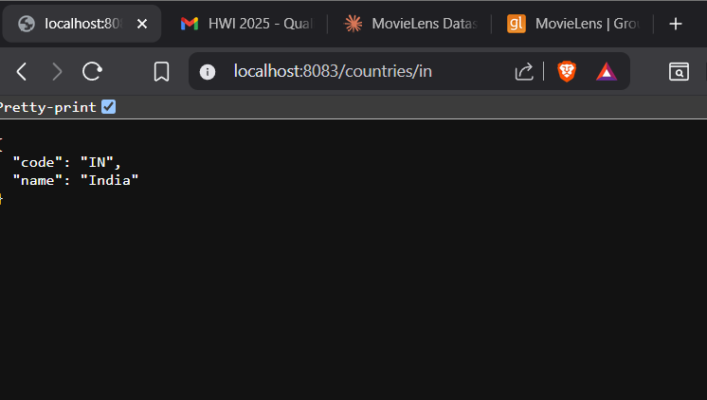In Network tab Hello request is tracked as the page is refreshed every time.